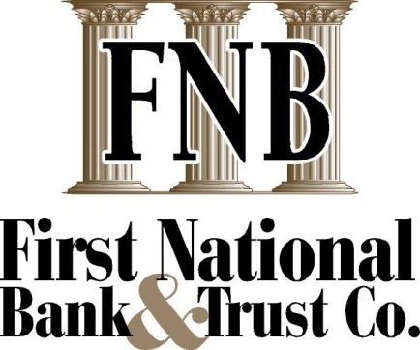
Position Title: | Commercial Lender
Date: | February 2022
Department: | Lending
Location: | OKC
Supervises: | Loan Administrative Assistant
Reports To: | Chief Lending Officer
FSLA Status: | Exempt

Summary of position:
The Commercial Lender focuses on soliciting new profitable business relationships as well as developing and managing existing account relationships. This position prepares and presents loan requests in accordance with established policies and procedures and regularly reviews the credit quality of the existing loan portfolio in order to identify any credit risk changes.
Key job functions: (Includes current duties, primary objectives, and responsibilities which are critical to the successful performance of the position)
- Performs an extensive amount of business development activities in the business community to develop growing network of outside referral sources for new business
- Gathers related financial and general business information, performs financial analysis needed to make credit decisions, participates in team credit decisions and communicates with prospects and customers to close sales
- Approves or rejects loan applications within individual lending authority
- Recommends credit decisions on loans over assigned limits to appropriate level of management
- Responsible for the proper credit administration of individual loan portfolios including loan closing, documentation, monitoring, on-going financial performance of borrowers, collateral inspections, collection of delinquencies and work-out of problem loans
- Maintains a working knowledge of commercial and other products and services, including loan policy, documentation, structuring and regulatory requirements
- Reviews and makes determination of insufficient items within bank guidelines
- Participates in weekly loan meetings by teleconference
- Participates in bank sponsored functions, as required
- Consistently promotes the Bank in a positive manner to community, customers, and staff
- Other duties as assigned
Qualifications:
- Strong analytical and business judgment skills
- Above average communication skills, including written, verbal, and coaching
- Previous experience in developing and managing a commercial loan portfolio
- Must be computer literate; proficient in Excel, Word and loan documentation programs
Education and Experience:
- Bachelors degree, preferably with an emphasis in Business, Finance or Accounting or 3 plus years commercial lending experience
- Advanced knowledge of bank compliance regulations, policies and procedures
Physical Demands: These physical demands are generally representative of the position.
- Hearing, speech, close vision
- Sitting, including computer use
- On occasions, may be required to lift and/or move up to 25 pounds

